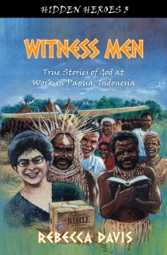
For information about the Hidden Heroes series of true missionary stories for children, click on the tabs above. So far there are books based in Ethiopia, Central African Republic, Southeast Asia, with more to come!
The blog?
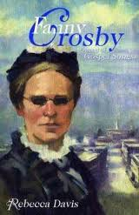
Sometimes it's news about missionaries or my books, but mostly it's what the Lord has been teaching me lately. As my daughter observed, it's just my online personal devotions.
